INDOXACARB
612

ISO Common name Indoxacarb

Chemical name (S)-7-chloro-3-[methoxycarbonyl-(4-trifluoromethoxy-phenyl)-carbamoyl]-2,5-dihydro-indeno[1,2-e][1,3,4]oxadiazine-4a(3H)-carboxylic acid methyl ester (IUPAC)

(S)-methyl 7-chloro-2,5-dihydro-2-[[(methoxycarbonyl)[4-(trifluoromethoxy)= phenyl]amino]carbonyl]indeno[1,2-e][1,3,4]oxadiazine-4a(3H)-carboxylate (CAS 173584-44-6)

Empirical formula C₂₂ H₁₇ Cl F₃ N₃ O₇

RMM 527.837

m.p. 88.1ºC

Solubility In water 0.20mg/L (25°C). In n-hexane 1.307 g/L, methanol 109.9 g/L, n-octanol 11.31 g/L, acetone >250 g/L, acetonitrile >250 g/L, ethyl acetate >250 g/L, dichloromethane >250 g/L, dimethylformamide >250 g/L, o-xylene >250 g/L (all at 20°C)

Description Off-white crystalline solid

Stability Aqueous hydrolysis: DT₅₀ >30 d (pH 5), 38 d (pH 7), 1 d (pH 9).

Formulations 150 SC: Suspension concentrate (SC)
30 WG: Water dispersible granules (WG), Dry Flowable
150 EC: Emulsifiable concentrate (EC)
1. Sampling.

- Identity Tests.

  - HPLC. Use the HPLC method below. The relative retention time of the indoxacarb peak in the sample solution should not deviate by more than 5% from that of the calibration solution and the UV spectrum measured from this peak should match that obtained from the calibration substance.

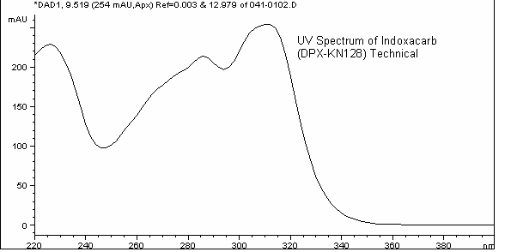

  - Infrared (IR). Prepare potassium bromide discs for the technical sample and indoxacarb reference substance. Formulated samples: mix 100 mg of formulation with 5-10 mL of acetonitrile, mix well, and filter. Evaporate the filtrate to dryness and prepare potassium bromide discs from the residues. The spectra from the samples should not differ significantly from that of the reference substance.

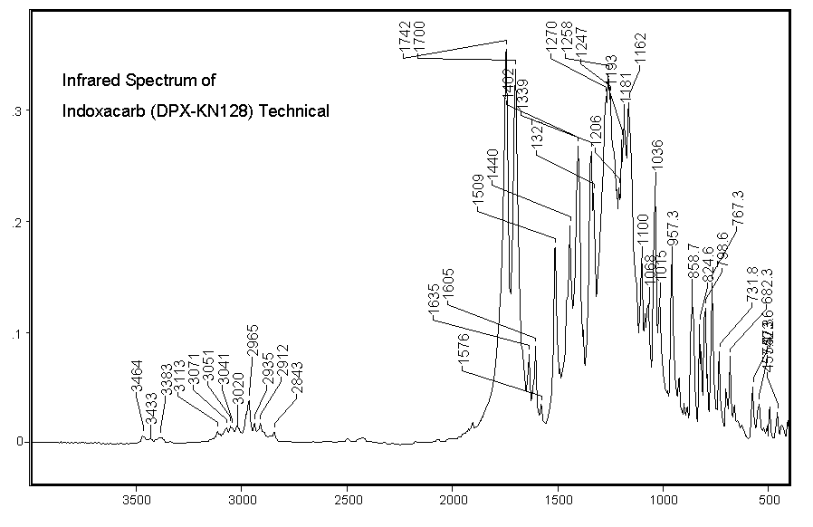

3. Indoxacarb

OUTLINE OF METHOD

A solution of the sample is analyzed by chiral normal-phase high performance liquid chromatography using a 4.6 mm x 25 cm Chiralcel OD column. The mobile phase is composed of 75% hexane (or heptane) and 25% 2-propanol. Indoxacarb is detected with a UV detector at 310 nm. The weight percent of indoxacarb in each sample is determined by comparing its peak area against a calibration curve prepared from the analysis of standard solutions.

The following explanation is provided in order to avoid possible confusion about the standard and samples. Indoxacarb is an optically active compound. DPX-KN128 is the active enantiomer and IN-KN127 in the inactive enantiomer. The purpose of the method is to measure the amount of the active enantiomer, DPX-KN128. The standard and samples use additional codes to refer to the approximate ratio of enantiomers:

DPX-JW062 is a racemic mixture (exactly 50:50 ratio of DPX-KN128 and IN-KN127). The analytical standard is DPX-JW062. The label purity of the standard is 99.6% which means that it contains 49.8% DPX-KN128 and 49.8% IN-KN127.

DPX-MP062 TK, SC, and WG samples contain DPX-KN128 and IN-KN127 in a ratio of approximately 75:25.

DPX-KN128 TC and EC contain DPX-KN128 only, without IN-KN127.

REAGENTS

Hexane (or Heptane) HPLC grade

2-propanol HPLC grade

Ethyl acetate HPLC grade

Water De-ionized, HPLC grade

Indoxacarb analytical standard of known purity

Mobile phase 75% (v/v) hexane (or heptane)/25% (v/v) 2-propanol. To a 1-L bottle, add 750 mL of hexanes (or heptane) and 250 mL of 2-propanol. Mixing of mobile phase also may be accomplished using a binary solvent HPLC pump. Mobile phase must be degassed prior to use.

Calibration solutions. Accurately weigh (to at least 0.1 mg precision) 50, 100, and 150 mg (± 5 mg) of DPX-JW062 (racemic) indoxacarb standard into separate 100 mL volumetric flasks. Add approximately 90 mL of ethyl acetate and ultrasonicate for 15 minutes. Remove the flasks from the sonicator and let stand to equilibrate to room temperature, about one hour. Dilute to volume with ethyl acetate and mix well. Filter a portion of each standard solution through a 0.2 μm filter prior to HPLC analysis. Note that in a chiral separation 50, 100, and 150 mg of DPX-JW062 is equivalent to 25, 50, and 75 mg of DPX-KN128.

APPARATUS

High performance liquid chromatograph equipped with a constant-flow pump, constant-temperature column compartment, a sample injector capable of injecting 5-µL aliquots, a UV detector (310 nm analytical wavelength; 450 nm reference wavelength) and digital integrator or other data-handling capability.

HPLC column Chiralcel OD, 25.0 cm x 4.6 mm, 10 μm particle size.
WARNING: Please read the literature with the column. This column must only be exposed to hexane (or heptane) and 2-propanol. Water or even acetonitrile would ruin the column. It is important to flush all lines of the instrument with about 10-20 mL 2-propanol, and then 15 - 20 mL of 75:25 hexane (or heptane):2-propanol mixture before the column is installed in order to remove aqueous or acetonitrile mobile phases from the mixing chamber and degasser portions of the instrument.

Filtering apparatus (for sample and standards solutions) disposable plastic 3 cc syringes fitted with 0.2 µm (or 0.45-µm) Acrodisc®-CR (PTFE or Teflon®) filters.

Ultrasonic bath

PROCEDURE

(a) Operating Conditions

Column Chiralcel OD, 25 cm x 4.6 mm, 10-μm particle size.

Mobile Phase 75% (v/v) hexane (or heptane)/25% (v/v) 2-propanol (see above for preparation).

Eluent flow rate 1.0 mL/min

Column temperature 40 °C

Injection volume 5 µL

Detection wavelength 310 nm (bandwidth 4 nm)
Reference wavelength 450 nm (bandwidth 100 nm)

Retention Time DPX-KN128 (active ingredient indoxacarb): 9.5 min.
DPX-KN127 (inactive enantiomer): 6.9 min.

Analysis Stop Time 12 minutes

(b) Sample preparation. Mill or grind all samples thoroughly prior to weighing. Refer to the table below and accurately weigh (to at least 0.1 mg precision) the amount of sample indicated into a 100 mL volumetric flask.

Sample Type | Amount (mg)
DPX-KN128 TC | 65 ± 10
DPX-MP062 TK | 110 ± 10
DPX-MP062 150 g/L Suspension Concentrate (SC) | 430 ± 10
DPX-MP062 30% Water Dispersible Granule (WG) | 220 ± 10
DPX-KN128 150 g/L Emulsifiable Concentrate (EC) | 430 ± 10

Samples (except WG)
Add about 90 mL of ethyl acetate to the flask containing the sample. Mix well and sonicate for 15 minutes. Remove the flasks from the sonicator and let stand to equilibrate to room temperature, about one hour. Dilute to volume with ethyl acetate and mix well. Filter a portion of the sample solution through a 0.2 µm filter prior to HPLC analysis.

WG Samples.
Add 4 mL of HPLC-grade water to the flask containing the sample. Take care to keep the sample at the bottom of the flask. Do not add the water so fast that some of the sample moves up the glass and sticks to the side of the flask. Swirl gently to disperse the granules.

Add about 10 mL of 2-propanol, swirl to mix, and add 70 mL of ethyl acetate. Mix well and sonicate for 15 minutes. Remove the flasks from the sonicator and let stand to equilibrate to room temperature, about one hour. Dilute to volume with ethyl acetate and mix well. Filter a portion of the sample solution through a 0.2 µm filter prior to HPLC analysis.

(c) Determination. Equilibrate the column with mobile phase until a stable baseline is obtained. Inject, in duplicate, 5 µL each of a solvent blank (ethyl acetate), standards, and samples, bracketing the samples with calibration standards.

(d) Calculation. Prepare a calibration curve for indoxacarb by plotting the peak areas versus the weights of the standards in milligrams, corrected for purity of the standard, and corrected to 50% of the purity as DPX-KN128 in the racemic DPX-JW062 analytical standard. Using the method of least squares, calculate the equation for the straight line which best fits the experimental calibration data. Typically, the correlation coefficient for such least square calculations is 0.999 or better.

Determine the concentration of indoxacarb for each sample injection using the following equation:

$\text{Wt}{\text{\%}}_{\text{indoxacarb}}=\left(\frac{\text{Peak}\text{Area}−b}{m×{\text{mg}}_{\text{sample}}}\right)×\text{100}\text{\%}$

Where, m = slope of least-squares line
b = y-intercept
mg_{sample} = weight of sample in milligrams

4. Suspensibility

Reagents and Apparatus as for MT 168 and CIPAC/xxxx/m, except:

Calibration solutions: Same as above. Prepare in the same way standard solutions at other concentrations, if needed. Filter a small portion of each solution through a 0.2-µm (or 0.45-µm) PTFE filter prior to analysis.

PROCEDURE

- Preparation of suspension and determination of sedimentation. MT 168.

- Determination of indoxacarb in the bottom 25 mL of suspension.
After removal of the top 225 mL of suspension, add to the remaining 25 mL 2-propanol (75 mL). Place the cylinder in an ultrasonic bath for 5 minutes. Allow to cool to room temperature, mix well by inverting the cylinder several times, then take a suitable aliquot of the solution for the determination of the mass of indoxacarb (Q g).

- Calculation
$\text{Suspensibility }=\frac{\text{111}(\text{c-Q})}{c}\text{\%}$,
where, c = mass of indoxacarb actually taken

Q = mass of indoxacarb in the 25 mL remaining in the cylinder

EXAMPLE CHROMATOGRAMS:

(a)

(b)

Figure 1. DPX-KN128 TC Sample run with mobile phase made with a) hexane, b) heptane

(a)

(b)

Figure 2. DPX-MP062 TK Sample run with mobile phase made with a) hexane, b) heptane

Heptane was used by one of the participants in the collaborative study and sample results were equivalent to those obtained with hexane. Also, see the chromatograms in the figures.

